**C PROGRAMMING PRACTICALS**

**sequential statement**

1. Area and perimeter of rectangle
2. Area and circumference of Circle
3. Roots of quadratic equations
4. Simple Interest
5. Swap Two numbers
6. Maximum of Three numbers
7. Number is even or odd
8. Finding the type of triangle
9. Sign of number
10. Calculator

***PRACTICAL NO.1 01/08/23***

***SEQUENTIAL AND CONDITIONAL PROGRAMMING***

*1*

***AIM: To find the area and perimeter of rectangle.***

***ALGORITHM:***

1. *start*
2. *declare l,b,area,perimeter as integer*
3. *Input l and b*
4. *Calculate area=l*b*
5. *Perimeter=2*l+2*b*
6. *Display area and perimeter*
7. *Stop*

***CODING:***

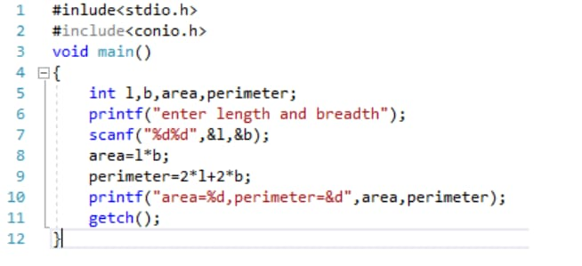

***OUTPUT***

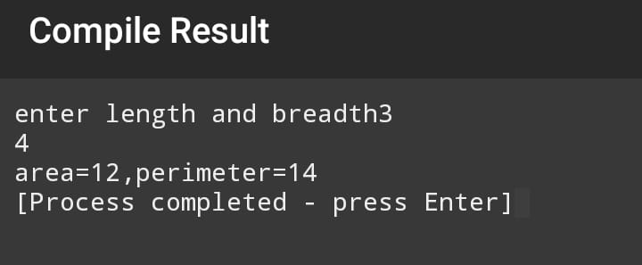

*2*

***AIM:To find area and circumference of circle***

***ALHORITHM:***

1. *Define radius and pi=3.142 as float*
2. *Input radius*
3. *Calculate circumference=2*pi*r*
4. *Calculate area=pi*r*r*
5. *Display circumference and area*
6. *Stop*

***CODING***

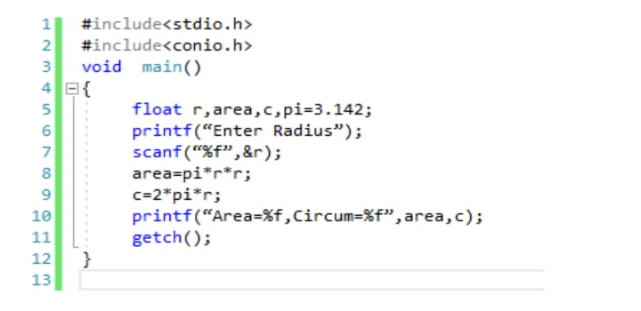

***OUTPUT***

*b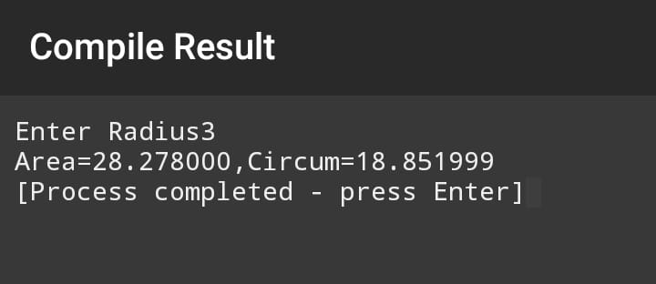*

*3*

***AIM: to swap two numbers***

***ALGORITHM***

1. *Start*
2. *Declare a,b,c as integers*
3. *Input a and b*
4. *c==a*

*a==b*

*B==c*

1. *Print a and b*
2. *stop*

***CODING***

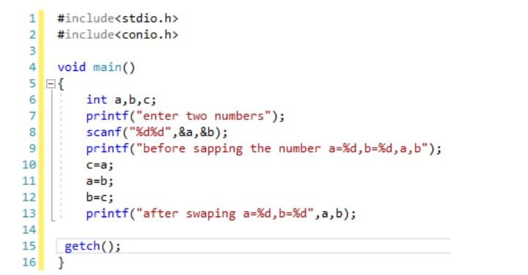

***OUTPUT****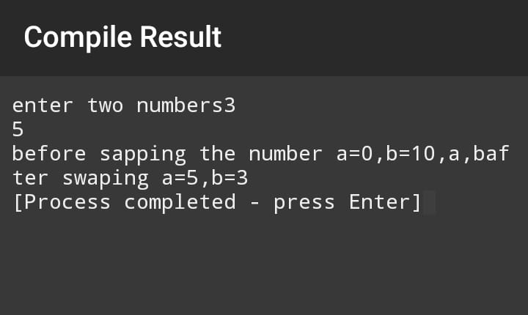*

*4*

***AIM: To find simple interest***

***ALGORITHM****:*

1. *Start*
2. *Define principle,period,ROI and SI as float*
3. *Input principle,period,ROI*
4. *Calculate SI=(P*N*R)/100*
5. *Display SI*
6. *Stop*

***CODING****:*

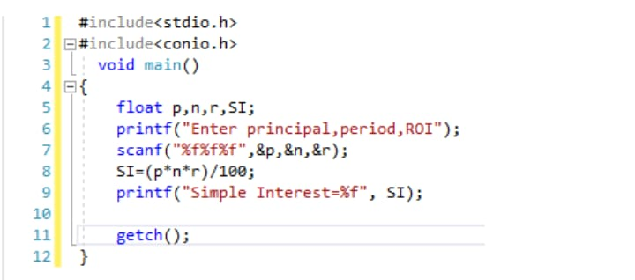

***OUTPUT***

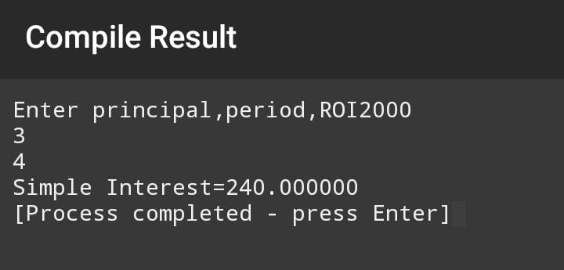

*5*

***AIM: to find roots of quadratic equation***

***ALGORITHM****:*

1. *Start*
2. *Let a,b,c,x,y,d be floatto*
3. *Input a,b,c*
4. *Calculate d=b*b-4*a*c*
5. *If d<0 roots are imaginary go step 9 else go to 6*
6. *Calculate x=-b-squrt(d)/2*a*
7. *Calculate y=-b+squrt(d)/2*a*
8. *Print values of x and y*
9. *Display imaginary*
10. *Stop*

***CODING****:*

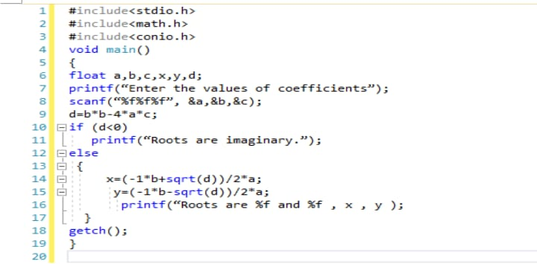

***OUTPUT****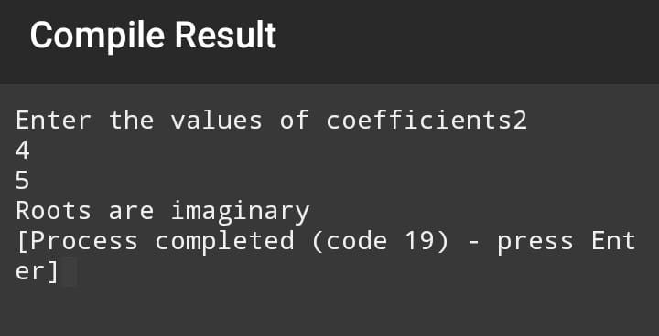*

*6*

***AIM: to find the maximum of the number***

***ALGORITHM***

1. *Start*
2. *Declare a,b,c as an integer*
3. *Input a,b,c*
4. *If a>b and a>c then display a*
5. *Else if b>c then display b*
6. *Else display*
7. *stop*

***CODING****:*

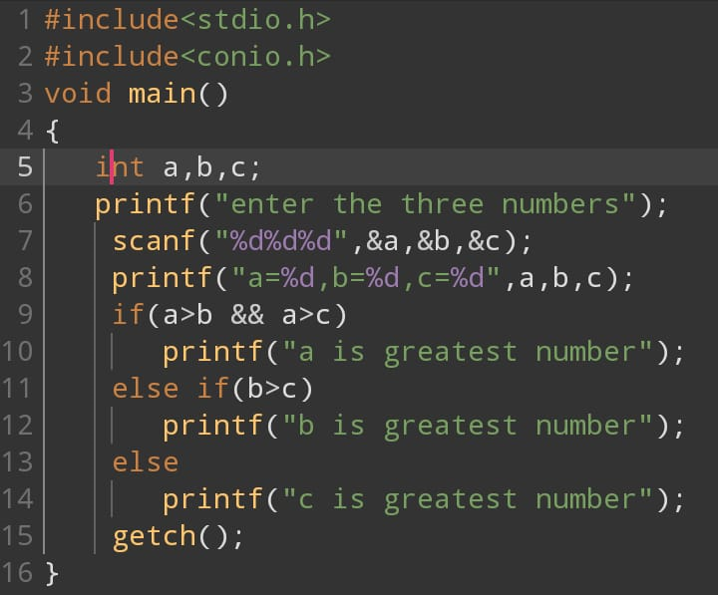

***OUTPUT***

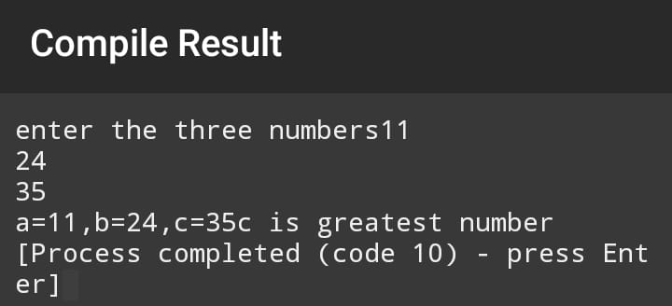

*7*

***AIM: to find sign of a number***

***ALGORITHM:***

1. *Start*
2. *Declare x as an float*
3. *Input x*
4. *If x>0, then display number is positive*
5. *Else if x<0, then display number is negative*
6. *Else x = 0, then display number is neutral*
7. *Stop*

***CODING***

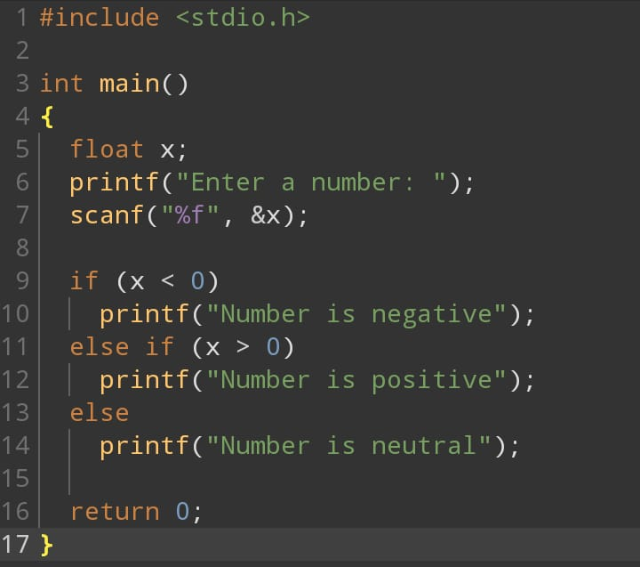

***OUTPUT***

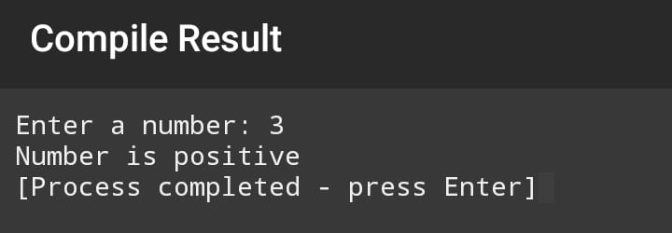

*8*

***AIM: to find the number is even or odd***

***ALGORITHN****:  
1.start*

1. *let the number n*
2. *Input n*
3. *If n mod 2==0 then display the number is even*
4. *Else display the number is odd*
5. *Stop*

***CODING***

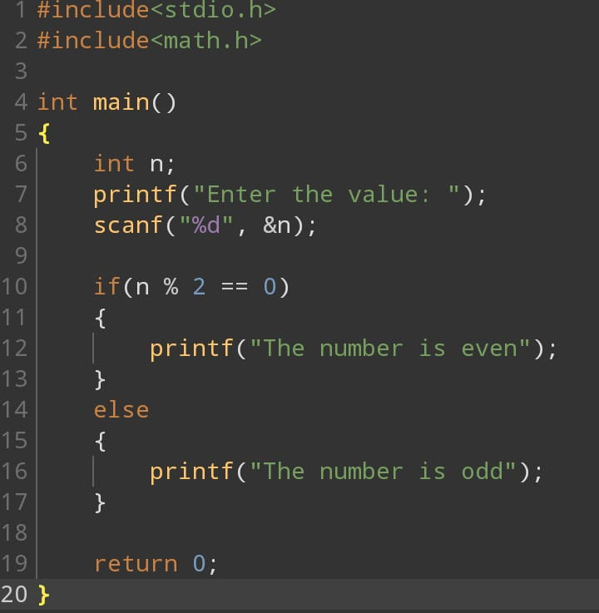

***OUTPUT***

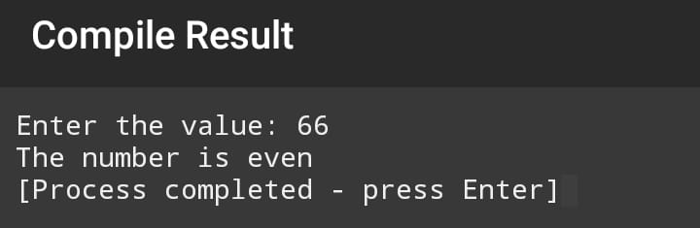

*9*

***AIM: to identify whether the triangle can be formed or not and describing its type***

***ALGORITHM****:*

*1.Start*

*2. Let sides of triangle be stored in variables s1, s2, s3 as integers*

*3.Input S1,s2 and s3*

*4. if s1+s2 > s3 or s1+s3 > s2 or s2+s3 > s1 then goto 5*

*else print "Triangle cannot be formed" goto 1*

*5. if s1= s2 and s2= s3 and s1=s3 then print "triangle is equilateral"*

*5. else if s1=s2 or s2=s3 or s1=s3 print "triangle is isosceles"*

*6. else print "triangle is scalene"*

*7. Stop*

***CODING****:*

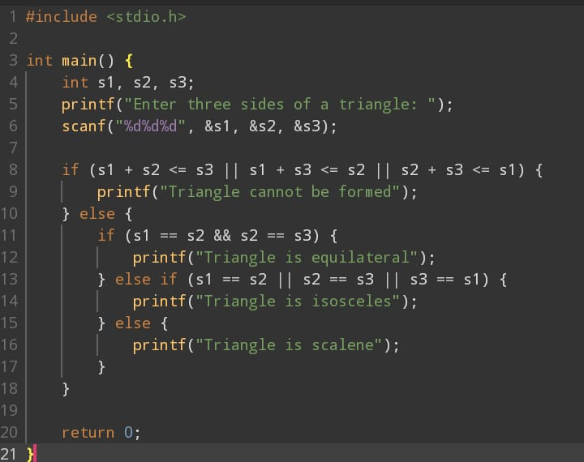

***OUTPUT***

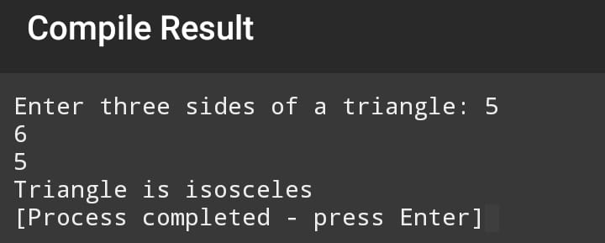

***10***

***AIM:to build a simple arithmetic calculator***

***ALGORITHM***

*1.Start*

*2.Declare a, b, add, sub, div, multi as integers operator as character*

*3.Input a & b*

*4.Input the operator*

*5.If operator= ‘+’ then display add = “a+b”*

*6.If operator= ‘-’ then display sub = “a-b”*

*7.If operator = ‘*’ then display multi=”a*b”*

*8.If operator = ‘/’ then display div=”a/b”*

*9.Stop*

***CODING***

*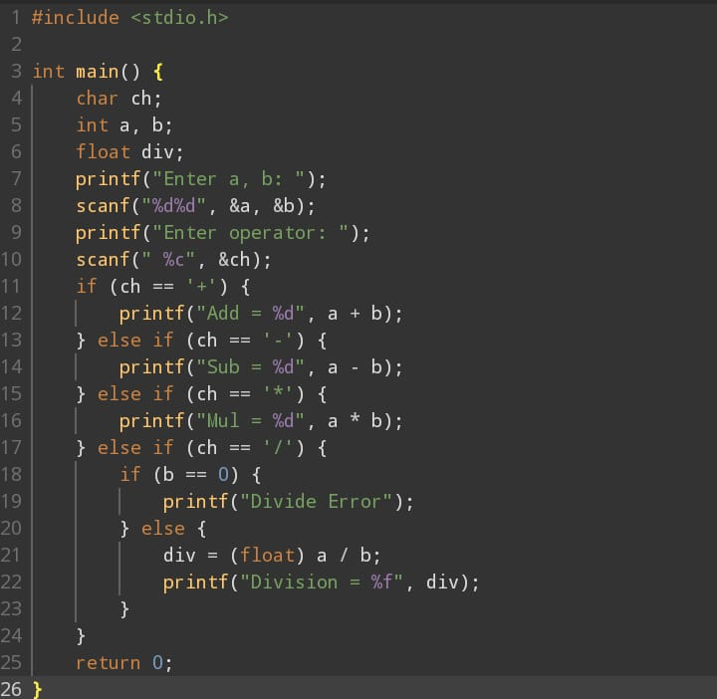****OUTPUT****:*

